Q3-kubernetes

* Create a yaml file for the nginx pod
* Create a volume to persist the static html content
* File serving
* Verify the pod and content served by nginx

1. **Created a persistent volume**

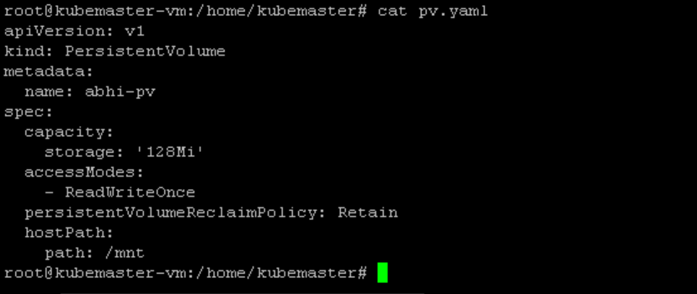

1. **Kubectl get pv** :

to see the pv created



1. Created a pvc (**persistent volume claim)**

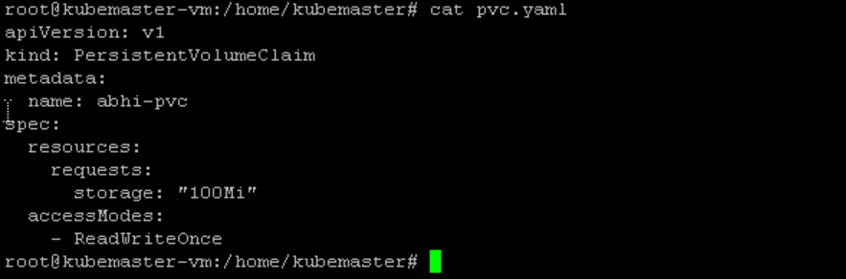

1. Kubectl apply -f pvc.yaml : to create pvc
2. Kubectl get pvc

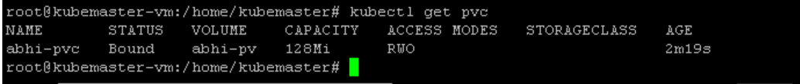

* Now pv and pvc bounded and they have one to one relationship

1. Creating a pod using name nginxpod



* now i want to edit the yaml file to include the volume

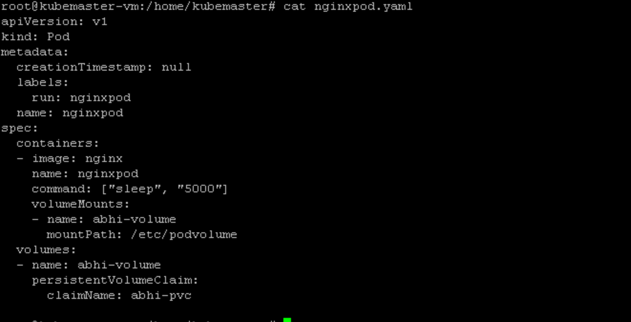

* here I configured with the volume I have created previously(pvc)
* kubectl get pods

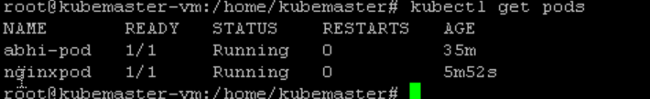

1. content serverd by /usr/share/nginx in the pod

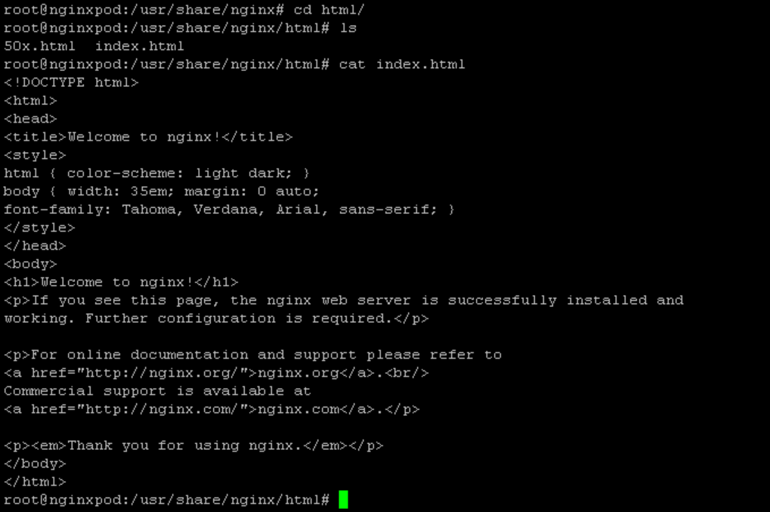

1. Created files inside the pod where the volume is attached and validated

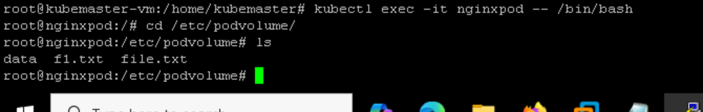

1. Validating the file is present in hostpath:

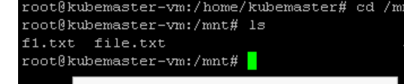

1. validated